CODE ALPHA

Project report
Results:
The network sniffer successfully captured network packets and displayed source IP addresses, destination IP addresses, and protocol information. The captured traffic demonstrated real-time network communication and packet analysis.

Conclusion
A basic network sniffer was successfully developed using Python and the Scapy library. The tool captured and analyzed network packets, helping in understanding network communication and packet structures. This project provided practical exposure to packet sniffing and network monitoring techniques used in cybersecurity.

Folder Structure
CodeAlpha_Task1
│
├── network_sniffer.py
├── Screenshots
│ ├── code.png
│ ├── install.png
│ ├── running.png
│ └── output.png
└── Report.docx

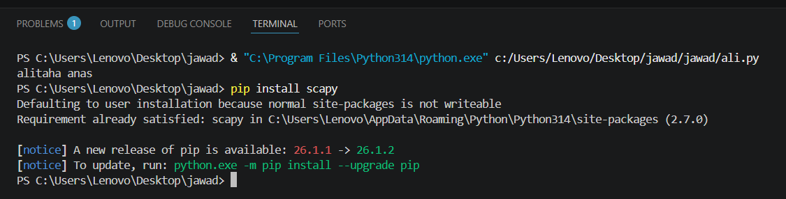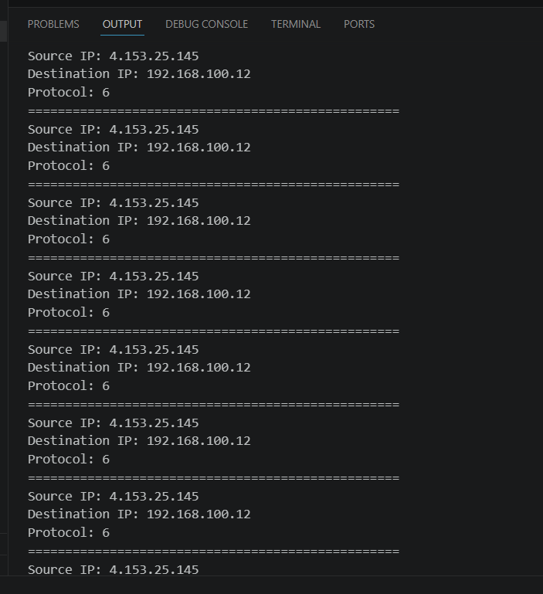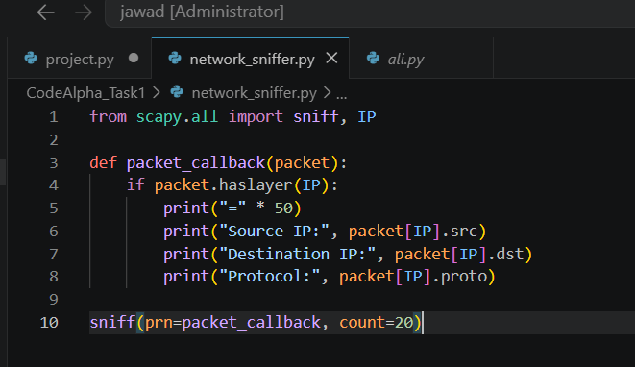s

